Chemistry Paper 4 Notes
Precision
Instrument | Uncertainty in measurement | Uncertainty in calculation
Volume
Pipet | $$0.04/0.06 {cm}^{3}$$ | $$1 d.p.$$
Burette | $$0.1 {cm}^{3}$$ | $$2 d.p.$$
$100 {cm}^{3}$ Measuring cylinder | $$0.5 {cm}^{3}$$ | $$3 d.p.$$
$250 {cm}^{3}$ Measuring cylinder | $$1 {cm}^{3}$$
Mass
Electronic Mass Balance | $$0.1 g$$
Spring Balance | $$5 g$$
Temperature
Mercury thermometer | $$0.1 ℃$$
Alcohol thermometer | $$0.5 ℃$$
Time
Stopwatch | $$Reaction time (0.2s)$$

General Experimental Techniques
- Weighing mass
- Subtraction method
Mass of container /g
Mass of container and chemical /g
Mass of container and residue chemical /g
Mass of chemical used /g
- Tare method
$$Mass of chemical used=x g (TARE)$$
- Titration
Titration | 1 | 2
Initial burette reading / ${cm}^{3}$
Final burette reading / ${cm}^{3}$
Volume of solution used / ${cm}^{3}$
$$Average volume of solution used =\frac{V_{1}+V_{2}}{2}$$
*Repeat to obtain two consistent tires within $0.10 {cm}^{3}$ in difference
*Add titrant from burette dropwise near end point
- Types of titration:
  - Acid-base
    - WRITE OUT EQUATION (pay attention to coefficients when diprotic acid/base is used)
  - Redox
  - Thermometric
- Indicator (for acid-base titration)
Titration | pH change | Indicator | Colour change
strong acid – strong base | 4 – 10 | methyl orange (3.1 – 4.4) | red – orange – yellow
 |  | thymolphthalein (9.3 – 10.5) | colourless – pale blue - blue
strong acid – weak base | 3.5 – 6.5 | methyl orange (3.1 – 4.4) | red – orange – yellow
weak acid – strong base | 7.5 – 10.5 | thymolphthalein (9.3 – 10.5) | colourless – pale blue - blue
weak acid – weak base | no marked pH change | no suitable indicator  (a pH meter could be used and end-point can be determined by plotting a graph of pH against volume)
  - Indicator is suitable if:
    - working range of indicator falls within rapid pH change
    - colour change is distinct
- $Change in concentration = \frac{Change in amount}{Volume}$

- If a less concentrated titre is used, titration will be more accurate as for the same absolute uncertainty, a higher volume of titre is used, and hence smaller percentage error.

- If burette tip is not filled, the titre value will be higher than expected. The calculated amount of … will be higher than expected. The calculated amount of the … will be smaller than expected. Hence, the calculated percentage purity of the sample will be lower than actual.

- If apparatus (pipette) is not rinsed with solution, deionised water in the apparatus dilutes the … solution. Since less … is transferred into the conical flask, less … will be produced for titration. Therefore, … will be required for complete reaction.
Titre obtained will be lower than expected.

- Water of crystallization is usually less than 10

- Percentage uncertainty has a $±$!!!

- Gravimetric method is less reliable than titrimetric method as:
  - Temperature of dehydration cannot be controlled using a Bunsen burner. Hence, it is difficult to prevent decomposition of anhydrous salt when it is first formed.
Improvement: Carry out the dehydration in a vacuum oven under controlled temperature of $400 ℃$.
  - Anhydrous salt may absorb moisture form the air during cooling.
Improvement: Cool anhydrous salt in a desiccator before weighing.
Graph
- Extrapolate lines until “meet” vs “cross”

Energetics
Aim: Find $∆H$ or $[FAx]$ or percentage by mass by measuring $∆T$ ($∆T=T_{f}-T_{i} , T_{i}=weighted average \frac{T_{1} V_{1}+T_{2} V_{2} }{V_{1}+ V_{2}}$).
*Remember negative sign!!!
- Calorimetry
- Reactions with two solutions
  - e.g. Neutralization
  - $∆H=\frac{Q}{n}=\frac{mc∆T}{n}$ , where $n$ is the mole of water
- Reactions with solid and solution
  - e.g. metal + acid
  - $∆H=\frac{Q}{n}=\frac{mc∆T}{n}$ , where $n$ is the mole of limiting agent
Plot cooling curve
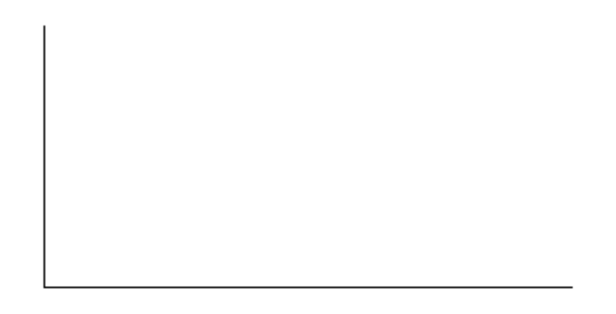
* Extrapolate to account for heat loss to environment
- Thermometric Titration
Volume of $x$ OR Mass of $x$ | Highest temperature
Plot two best-fit-line graph
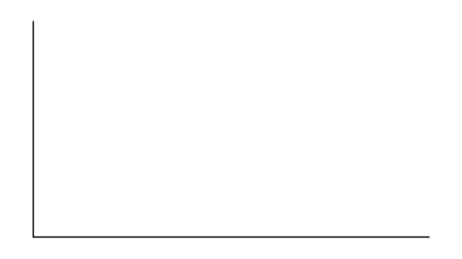OR 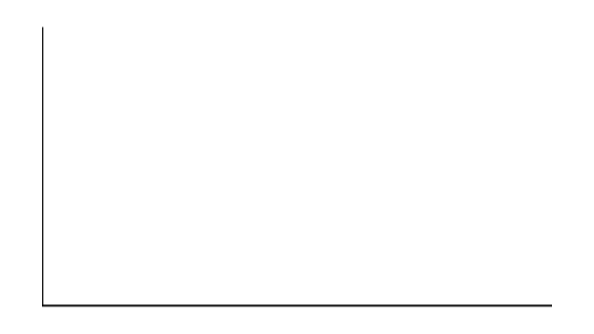
*if solid is added

- If a cooler environment is used, the titre value will be higher than expected. The lower temperature of environment results in the lower rate of reaction \

- Weak bases give a lower $T_{max}$ and hence a lower $∆T$.
Ethanoic acid, a weak acid, is partially dissociated in water whereas hydrochloric acid, a strong acid, is fully dissociated. Some of the heat evolved from neutralization is absorbed to dissociate the ethanoic acid molecules completely, resulting in a smaller $∆T$ at the equivalence point.

- Using a diprotic acid with half the concentration of the monoprotic acid used has no change on the mass of solid needed as same amount of $H^{+}$ is involved.

- Initial temperature of all solutions needs to be accounted for by using weighted initial temperature.

- Crucible is preferred over a boiling tube as it has a larger opening which allow the water vapour formed to escape easily.

- $∆H$ is different from $∆H$ calculated using bond energy values.
  - $∆H$ assumes that all substances are in their standard states. However, $X$ is in liquid / solid state while bond energies are calculated when it is in gaseous state.
  - Intermediate bond character: single bond having double bond character / double bond having triple bond character due to the delocalization of $π$ electron over molecule
  - Bond strain: Weakens the bond. Less energy is required to break the bond.
Sources of error | Precautions
Heat was lost to the surroundings. The maximum temperature recorded is lower than actual, resulting in a lower temperature rise than actual. Thus, the calculated heat evolved is lower than actual and $∆H$ is less negative than actual. | Carry out the experiment in a draught-free environment to minimise heat loss to the surroundings.  Use a polystyrene cup with a lid on to carry out the reaction.
The $50 {cm}^{3}$measuring cylinder has an absolute uncertainty of $0.5 {cm}^{3}$. This resulted in large percentage uncertainty for the volume of solutions measured. Thus, the calculated heat evolved and $∆H$ are inaccurate. | Use a burette instead of a measuring cylinder give rise to lower absolute uncertainty of 0.10 cm3 for volume of solution measured.  Each burette reading has an absolute uncertainty of $0.05 {cm}^{3}$. Due to lower percentage uncertainty for measured volumes of the solutions, the results are more accurate.
The thermometer reading has an absolute uncertainty of $0.1 ℃$ and the measured temperature rise is very small. This resulted in large percentage uncertainty for the temperature rise. Thus, the calculated heat evolved and $∆H$ are inaccurate. | Use a digital thermometer with a smaller absolute uncertainty to measure temperature more accurately.
There is a loss of material if the solution overflows or sprays out. | Use a larger cup/ container.  Cover the cup with a lid to minimise spray.

Reaction kinetics
Aim: Find order of reaction by measuring volume (since $volume∝concentration$ when total volume is constant) or rate by measuring $\frac{1}{time}$ AND
plotting graph of $\lg{Rate}=n\lg{[x]}+\lg{k}$, where n is the order of reaction.

- Titrimetric method – Continuous *Used when there is no visible change*
- Samples are collected from the reacting mixture and quenched by:
  - Rapid cooling by plunging mixture into ice
  - Diluting by adding a large quantity of water
  - Adding a quenching reagent which stops/slows down the reaction by completely removing a reagent
- Samples are then titrated to determine amount of reactant / product at each sampling time.

Change in conditions | Result
If a cooler environment is used | Titre value will be higher than expected. The lower temperature of environment results in the lower rate of reaction and hence a larger amount of product/reactant remains present in sample. A larger volume of $x$ is required for titration.  - A water / oil bath can be used to maintain the temperature at room temperature for the reaction.
If a much higher concentration of reactant $x$ is used | It remains relatively constant as very little proportion of it is consumed for reaction. Reaction is pseudo first order Hence, rate with respect to the specific reactant can be studied.
If experiment is done on another day | Temperature have changed  OR $H_{2}O_{2}$ would have decomposed
Zero order:
First order: 

- Clock reaction – Discontinuous *Used when there is a visible change*
- Measure time for visible change to occur
- Keep total volume constant such that volume can be used to represent concentration.
- Source of error:
  - Difficult to determine when visible change occurs
  - Human reaction time
Change in conditions | Result
Using a $250 {cm}^{3}$ instead of a $100 {cm}^{3}$ beaker | Results in a lower height of solution. More product is required to obstruct the same amount of light. Hence, time taken would be longer.
Stopwatch is started when about half of the solution has been added. | If stopwatch is only started when all the solution is added, the reaction would have started before the stopwatch is started. This will result in the experimental timing being shorter than actual.
- ${Mn}^{2+}$ ions act as a catalyst by providing an alternative pathway of lower activation energy. The reaction between ${MnO_{4}}^{-}$ and ${C_{2}O_{4}}^{2-}$involves two anions that repel each other, thus requires a high activation energy.
- $\frac{1}{t}$ can be used as rate as they are proportional only when total volume is fixed
If volume used in each experiment is different, rate is no longer proportional to $\frac{1}{t}$.

- Gravimetric / Mass loss method (Gas collection method)
- Volume of gas produced per unit time
- Mass loss per unit time

- To collect a dry sample of gas, use a well-greased gas syringe instead of downward displacement of gas method.

Sources of error | Precautions
The thermometer reading has an absolute uncertainty of $0.1 ℃$ and the measured temperature rise is very small. This resulted in large percentage uncertainty for the temperature rise. Thus, the calculated heat evolved and $∆H$ are inaccurate. | Use a digital thermometer with a smaller absolute uncertainty to measure temperature more accurately.
The volume of gas collected by downward displacement of gas is less than actual volume as some gas ($CO_{2}$) might have dissolved in water. Thus, amount of gas ($CO_{2}$) calculated is less than actual and the percentage of $CaCO_{3}$ in sample solid is less than expected. | Use a well-greased gas syringe.
During cooling process metal oxide may react with the air to form hydroxides or carbonates. | Cool in desiccator
To evaporate water of crystallization without decomposing the metal | Carry out the dehydration process in a vacuum oven under controlled temperature.

Planning
- Quantity
- Apparatus
- Specific action
Method
- State choice of apparatus
- Procedures
  - Weighing solids
1. Place clean and dry container on the weighing pan and close the draft shield doors.
2. Weight mass of container accurately.
3. Add required mass of solid into container and record the mass of container and its content.
4. Calculate mass of solid transferred using subtraction method.
  - Preparing solution by dilution
1. Transfer solid into CLEAN and DRY beaker.
2. Add small volume of deionised water to completely dissolve the solution.
3. Transfer solution to a volumetric flask.
4. Top up volumetric flask with deionised water until graduation mark.
5. Stopper the volumetric flask and shake to ensure homogeneous solution.
  - Preparing saturated salt solution
1. Transfer weighted solid into a CLEAN and DRY beaker
2. Add small volume of deionised water/specific solvent into the beaker and stir gentle using a glass rod to dissolve as much of solid as possible.
3. Repeat step 2 until some solid remains undissolved to ensure a saturated solution is obtained.
4. Leave the mixture to stand in constant temperature water bath for at least 30 minutes to allow equilibrium to be reached.
5. Filter the saturated solution into a DRY conical flask using a DRY filter funnel and filter paper to ensure the saturated solution is not diluted.
  - Heating solid (thermal decomposition)
1. Weigh mass of EMPTY, CLEAN and DRY crucible / boiling tube.
2. Add solid and weigh and record mass of $container + solid$.
3. Heat solid in boiling tube at $45°$ using non-luminous flame for at least 10 minutes.
4. Cool to room temperature and weigh mass of $container + its content$.
5. Repeat step 3 and 4 until mass of $container + its content$ is within $0.050 g$ in difference.
  - Collecting gas
Insoluble / Sparingly soluble | Moderate | Very soluble
$$CO, CO_{2}, H_{2}, N_{2}, O_{2}$$ | $${SO}_{2}, {Cl}_{2}$$ | $$NH_{3}, HCl, HBr, HI$$

Insoluble gas – Downward displacement of water
Set up:

Soluble gas – Well-greased Gas syringe
Set up:

  - Reflux set-up
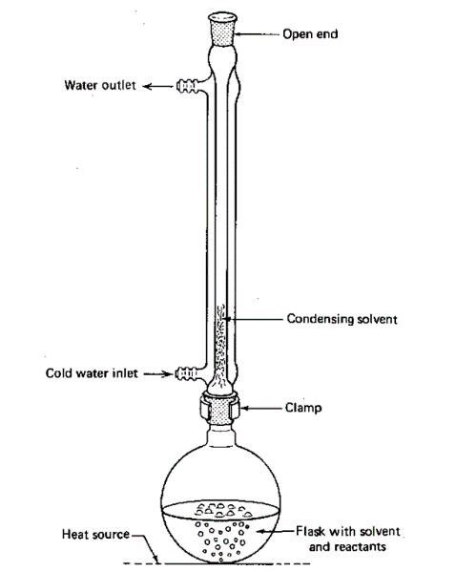
*Open end is to prevent pressure from building up and causing breakage

Variable / Measurement / Information
Energetics
Thermal decomposition
Mass of porcelain boat /g |  | A
Mass of porcelain boat and solid /g |  | B
Mass of solid /g |  | C
 | 1st Heating |  | 2nd Heating
Mass of porcelain boat and solid /g | D |  | E
, where $D-E<0.050 g$
Precaution / Reliability / Safety / Accuracy
- Always use BURETTE
- Turn off gas before titrating
- Switch off hot place after use
- Use a towel to handle the hot conical flask
- Hold the boiling tube with a test-tube holder to avoid direct contact with the hot boiling tube
- Use mortar and pestle with care
- DRY Styrofoam cup
- Set-up must be secured to prevent toppling and breakages
- Secure polystyrene cups by placing it in a beaker to prevent toppling
- Use a towel to hold the beaker
- Carry out the experiment in a draught-free environment to minimise heat loss to the surroundings.
- Use a burette instead of a measuring cylinder give rise to lower absolute uncertainty of 0.10 cm3 for volume of solution measured.
- Use a digital thermometer with a smaller absolute uncertainty to measure temperature more accurately.
- DRY filter paper and funnel and beaker
- DRY and CLEAN crucible
- COOL crucible to room temperature before weighing
- Heat at least 5 minutes for every heating cycle
- Make sure residue mass is consistent within 0.050g in difference
- Use a pair of metal tongs to handle the hot crucible / boiling tube.
- Use well-greased gas syringe to collect gas.
- *IF $H_{2}$ GAS EVOLVED* Pass an inert gas through the apparatus to flush out the $H_{2}$ gas.
Titration
- Specify indicator + colour change
- Add titrant from burette dropwise near end point
- Repeat to obtain two consistent tires within $0.10 {cm}^{3}$ in difference
Electrochem
- Place CLEAN and DRY beakers in thermostatically controlled water bath
- Salt bridge: Soak strip of filter paper in saturated potassium nitrate solution

